The lecture 8
Minimax algorithm in the game theory
Minimax is a kind of backtracking algorithm that is used in decision making and game theory to find the optimal move for a player, assuming that your opponent also plays optimally. It is widely used in two player turn based games such as Tic-Tac-Toe, Backgamon, Mancala, Chess, etc.
In Minimax the two players are called maximizer and minimizer. The maximizer tries to get the highest score possible while the minimizer tries to get the lowest score possible while minimizer tries to do opposite.
Every board state has a value associated with it. In a given state if the maximizer has upper hand then, the score of the board will tend to be some positive value. If the minimizer has the upper hand in that board state then it will tend to be some negative value. The values of the board are calculated by some heuristics which are unique for every type of game.
Example:
Consider a game which has 4 final states and paths to reach final state are from root to 4 leaves of a perfect binary tree as shown below. Assume you are the maximizing player and you get the first chance to move, i.e., you are at root, and your opponent at next level. Which move you would make as a maximizing player considering that your opponent also plays optimally?
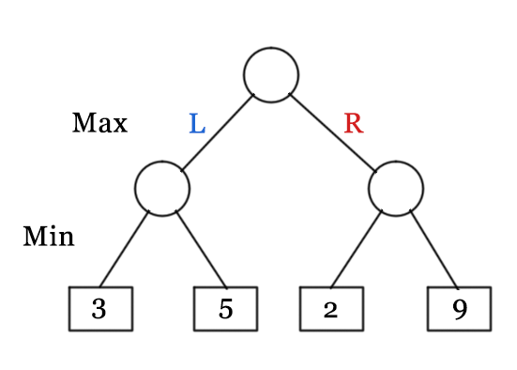
Since this is a backtracking based algorithm, it tries all possible moves, then backtracks and makes a decision.
- Maximizer goes LEFT: It is now the minimizers turn. The minimizer now has a choice between 3 and 5. Being the minimizer it will definitely choose the least among both, that is 3
- Maximizer goes RIGHT: It is now the minimizers turn. The minimizer now has a choice between 2 and 9. He will choose 2 as it is the least among the two values.
Being the maximizer, you would choose the larger value that is 3. Hence the optimal move for the maximizer is to go LEFT and the optimal value is 3.
Now the game tree looks like below:
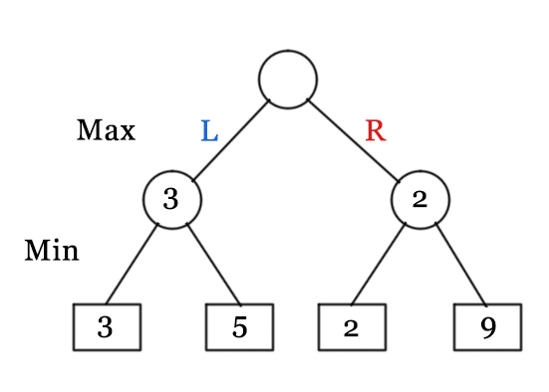
The above tree shows two possible scores when maximizer makes left and right moves.
// A simple C++ program to find maximum score that
// maximizing player can get.
#include<bits/stdc++.h>
using namespace std;
// Returns the optimal value a maximizer can obtain.
// depth is current depth in game tree.
// nodeIndex is index of current node in scores[].
// isMax is true if current move is of maximizer, else false
// scores[] stores leaves of Game tree.
// h is maximum height of Game tree
int minimax(int depth, int nodeIndex, bool isMax, int scores[], int h)
{
// Terminating condition. i.e leaf node is reached
if (depth == h)
return scores[nodeIndex];
// If current move is maximizer, find the maximum attainable
// value
if (isMax)
return max(minimax(depth+1, nodeIndex*2, false, scores, h), minimax(depth+1, nodeIndex*2 + 1, false, scores, h));
// Else (If current move is Minimizer), find the minimum
// attainable value
else
return min(minimax(depth+1, nodeIndex*2, true, scores, h), minimax(depth+1, nodeIndex*2 + 1, true, scores, h));
}
// A utility function to find Log n in base 2
int log2(int n)
{ return (n==1)? 0 : 1 + log2(n/2); }
// Driver code
int main()
{
// The number of elements in scores must be
// a power of 2.
int scores[] = {3, 5, 2, 9, 12, 5, 23, 23};
int n = sizeof(scores)/sizeof(scores[0]);
int h = log2(n);
int res = minimax(0, 0, true, scores, h);
cout << "The optimal value is : " << res << endl;
return 0;}

